How to export all SSIS packages to File location on the server.

http://www.sqldbaexperts.com/how-to-export-all-ssis-packages-to-file-location-on-the-server/
- There are multiple ways to copy SSIS packages from SQL to file location or vice versa.
- You can connect to SSIS and then export packages.
- This is manual and easy way to download the packages.
- But what if you have 100 SSIS packages on your server and what if you have 1000+ packages.
- Too much time consuming and tedious right.
- What if we can download all the packages with single run. Let’s see how to do it.
Connect to SSMS and run below command:
USE MSDB
SELECT 'EXEC XP_CMDSHELL ''DTUTIL /SQL ' + NAME +' /COPY FILE;
D:\SQLDBAExperts\Packages\' + NAME+'.DTSX' + ' /QUIET''' FROM SYSSSISPACKAGES

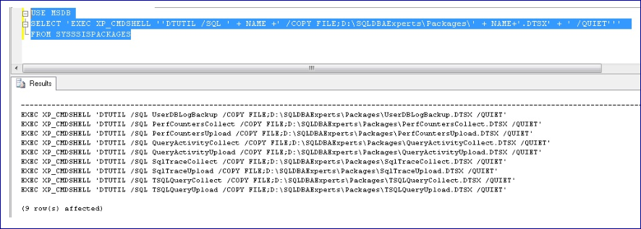

- Once you get the output as shows in screenshot.
- Copy output and run it in another query window.
- All the packages will be copied to specified location without any manual effort:

